1. Logical View
   1. Class Diagram

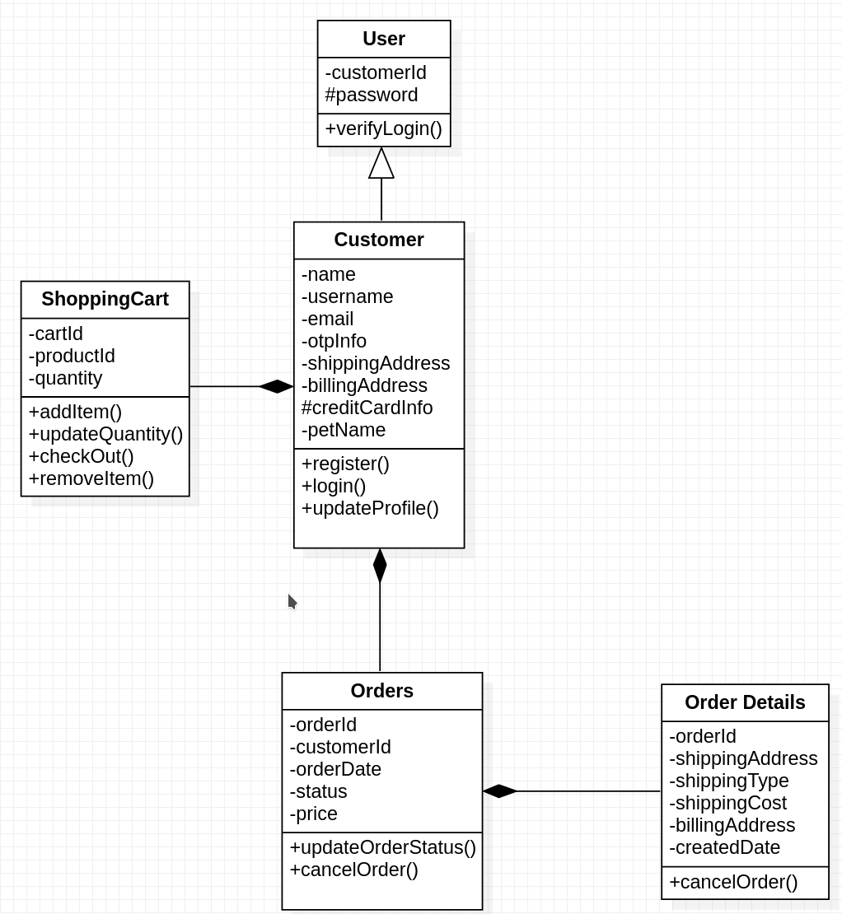

1. Process View
   1. Sequence Diagram

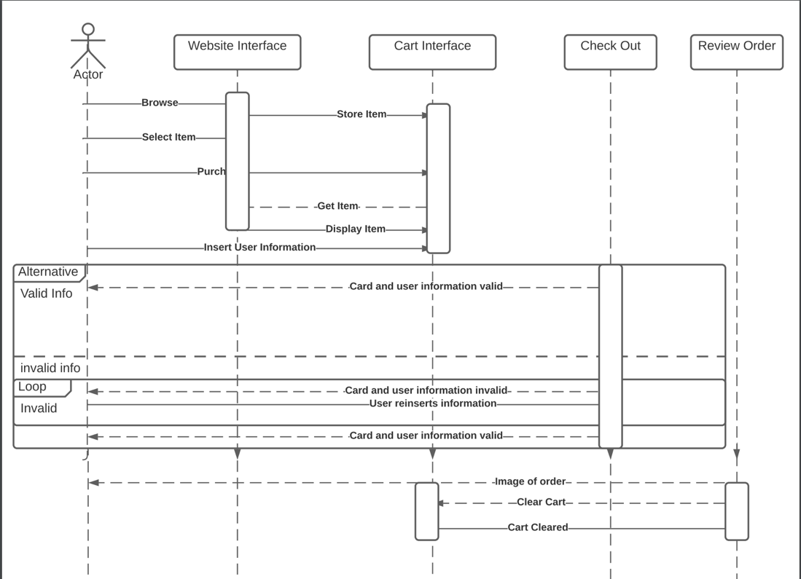

1. Development View
   1. Activity Diagram 1

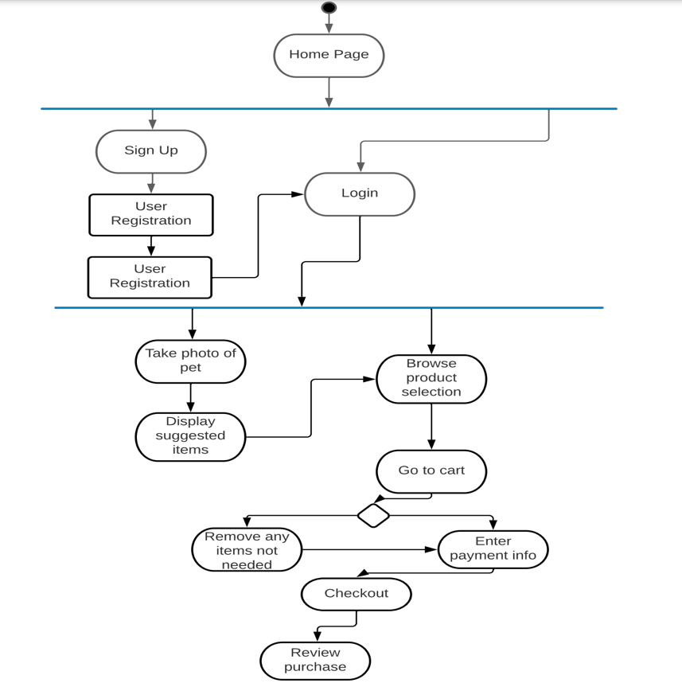

* 1. Package Diagram

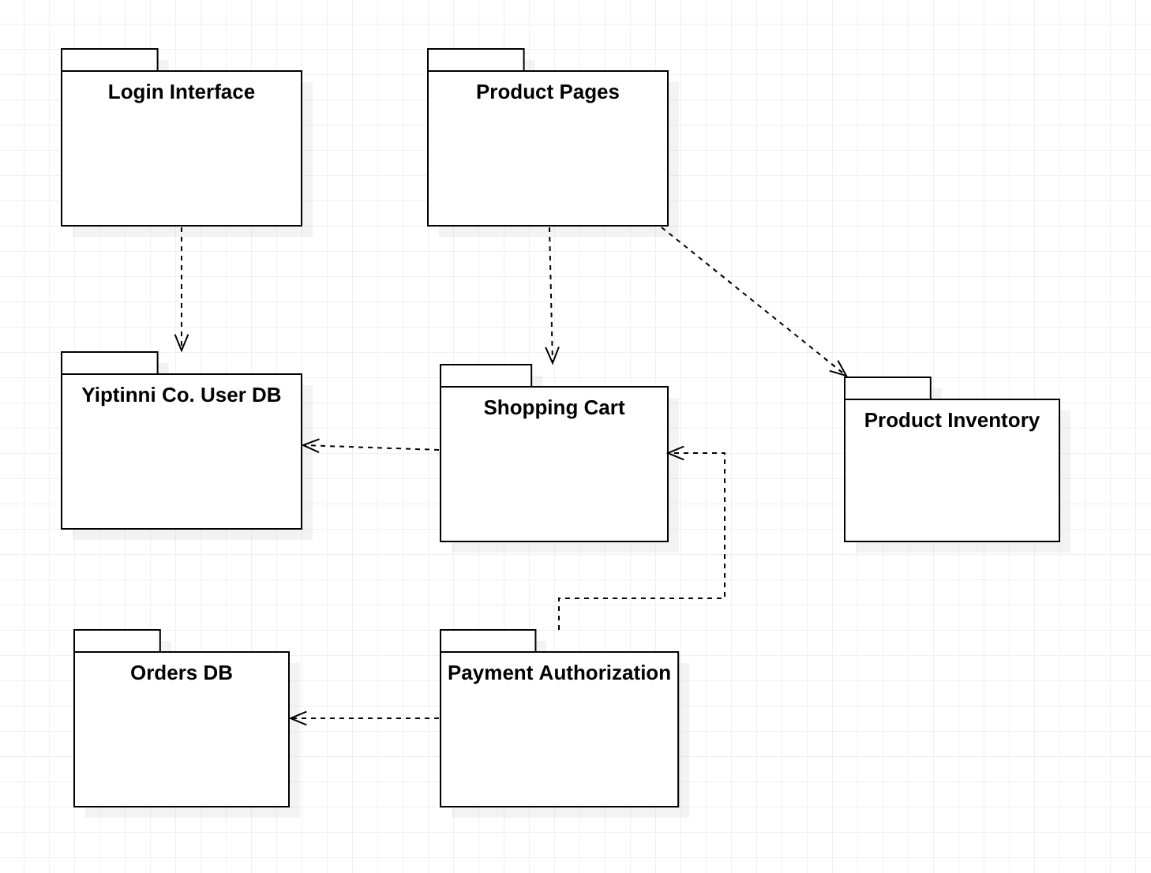

1. Physical View
   1. Deployment Diagram

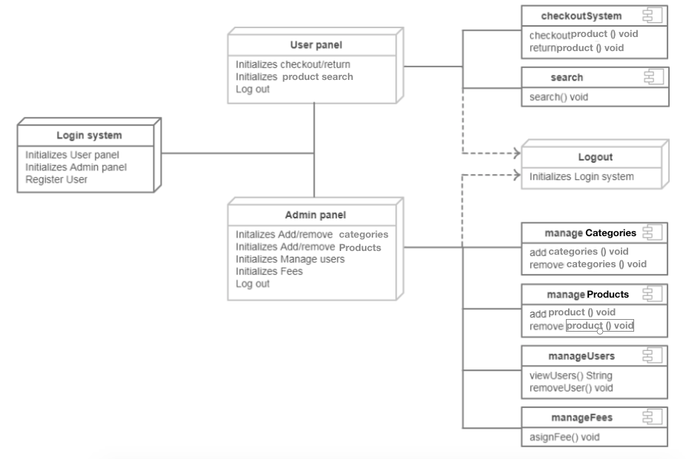

* 1. Network Topology
     1. 